Project Management
Name
Institutional Affiliation

Funds Raising Project: Hoops for Hope
Introduction
The initiation phase of a project usually entails the steps that must be taken before a project has been approved. The main focus is to ensure that the project has been tied to a high level for it to become an efficient process. During this step, the project will identify the amount of money that would be raised for the Downs Syndrome association. Setting aside the plan is key to ensuring that the number of T –shirts for the teams would be identified and planned for. The entry fee of $40 would also be used to determine effective planning process.
Process of Managing the project
The first step in this fundraising is to set goals to be accomplished in the project. This would improve the outcomes of the project and ensure that the goals of the project have been sufficiently accomplished. The second step is to draw a list of stakeholders that would improve the outcomes to be achieved in the project. The best way to do this is to establish a project charter that would direct every step to be accomplished in the project. The advertisement for the project would also be identified to ensure effective identification of a number of individuals who would be involved in this process has been identified. Identifying and documenting the stakeholders to be involved in the whole fundraising activity is essential to improved planning phase, which is key to the advancement of the fund raising activity. The third step is to plan the project so as to improve the success of accomplishing goals of the project. Planning involves setting a budget baseline and assigning responsibilities and roles to the individuals who would be involved in the planning phase (Larson & Gray, 2014).
The third step is to provide effective execution of the project for it to become a major success. Execution involves allocation of sufficient resources that would improve the performance of the project and achievement of necessary goals and objectives. Resources for making T-shirts and the caps to be sold during the fundraising needs to be identified. These resources are key to the improvement of the projects resources and outcomes. The other step is to ensure that individuals have met and fixed issues they have raised throughout the project. This would improve the success of the project by ensuring that the necessary objectives have been met in an efficient manner. There is a need to ensure that procuring and financing of the project has been achieved through effective planning process. This can be achieved through identification of goals to be accomplished and ideas to be set out in the project plan. The control and monitoring of projects progress is also key to improvement of key performances that ensure that the project is highly effective. Ensuring that monitoring and control of the project outcomes is also key to improvement of the project’s goals (Larson & Gray, 2014).
Project Evaluation Form
The project evaluation should be used as an efficient step for evaluation of the safety standards that should be met from the beginning stages of planning. A PG rating for the project needs to be identified to ensure that the fund-raising initiative meets the standards and guidelines for the PG or G meeting. This would provide a safety standard for evaluation of the project’s goals and initiatives. The following graph helps to provide a project evaluation form for the document. This would provide sufficient examination of the project.
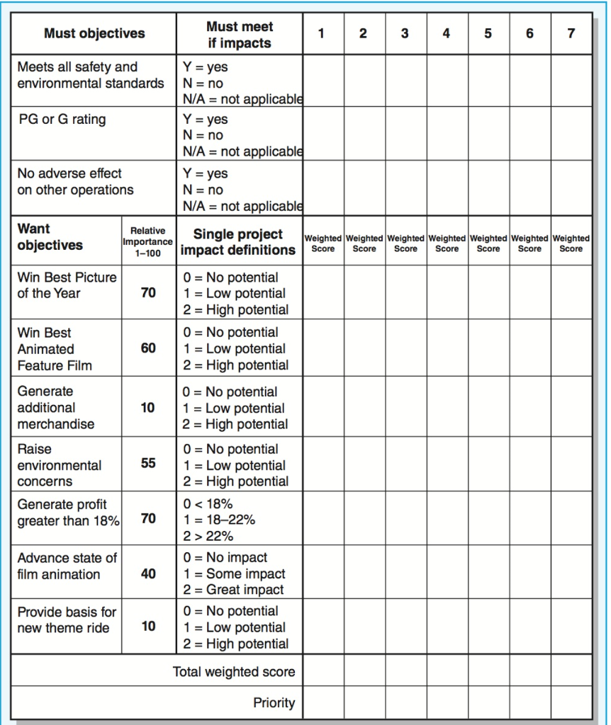
Conclusion
In sum, planning for a project is a good aspect for project management that involves establishing new goals and plans to be achieved in the project. The process of project management involves identifying of outputs and resources to be involved in the project. Ensuring stakeholders have been identified and given respective roles is key to ensuring that the project has succeeded in a more effective manner.
References
Larson, E. & Gray, C. (2014). Project management: The managerial process (6th Ed.). New York, NY: McGraw-Hill.

